**Git Commands Hands-On:**

git status command:

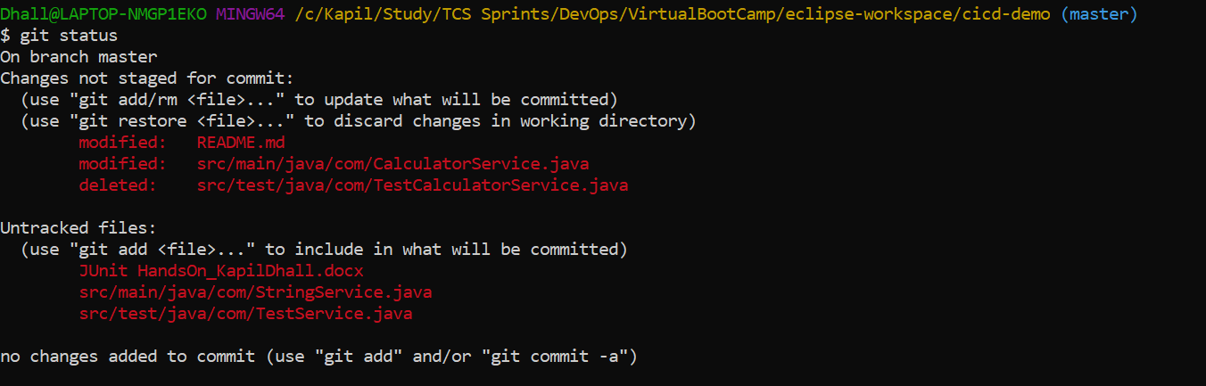

git add and git commit command:

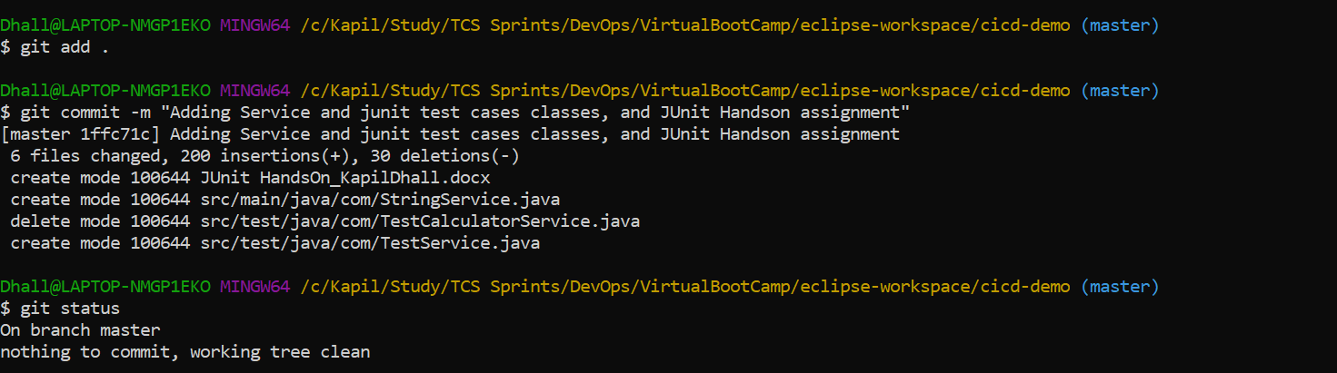

git push command:

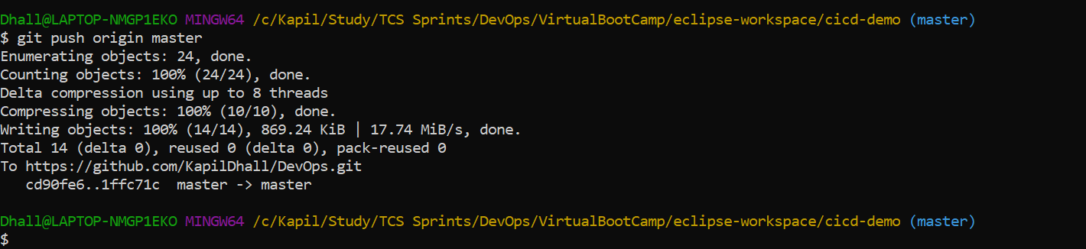

Branching:

git branch – To list all the branches

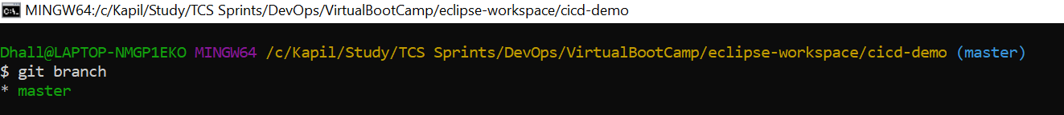

git branch $branchName - To create a new branch. We have created testBranch here

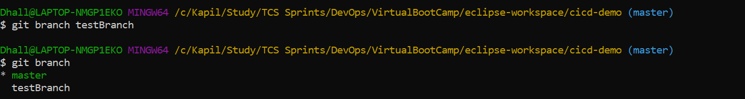

git checkout testBranch:

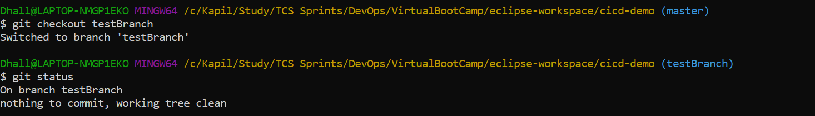

Modify Readme.md file in newly created branch:

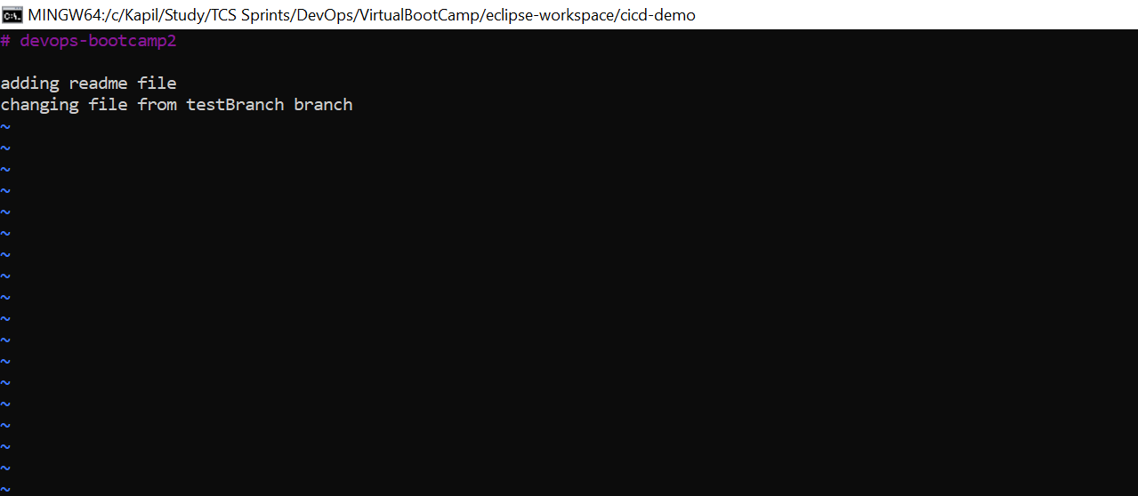

Add and commit changes in Readme.md file

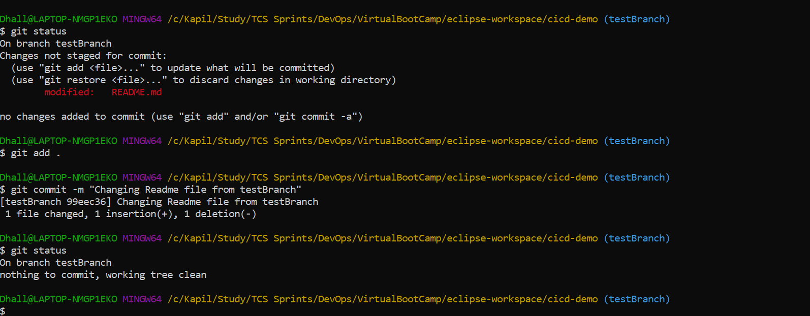

**To merge a child branch to master**

Checkout to master branch and run git merge $branchname command:

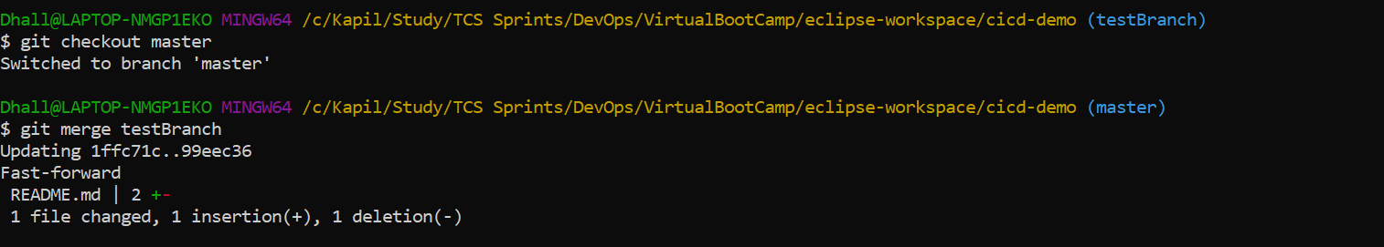

Delete an exisiting branch – run git branch –d $branchname:



Push the changes and verify in Github:

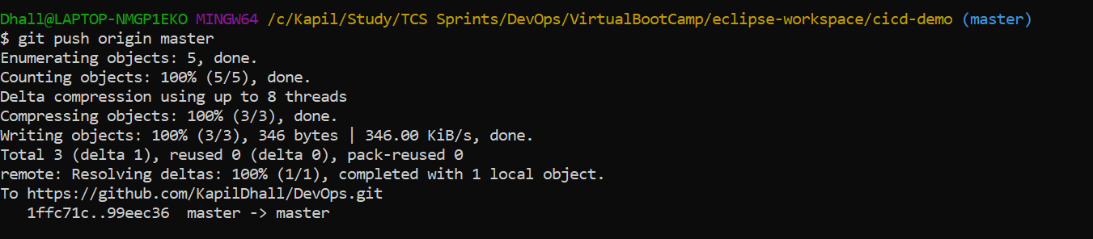

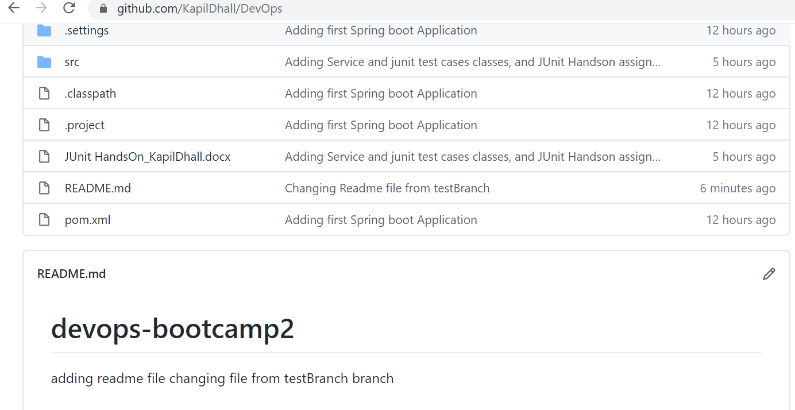

**Advance git commands**

Create newBranch and checkout. Modify Readme.md file

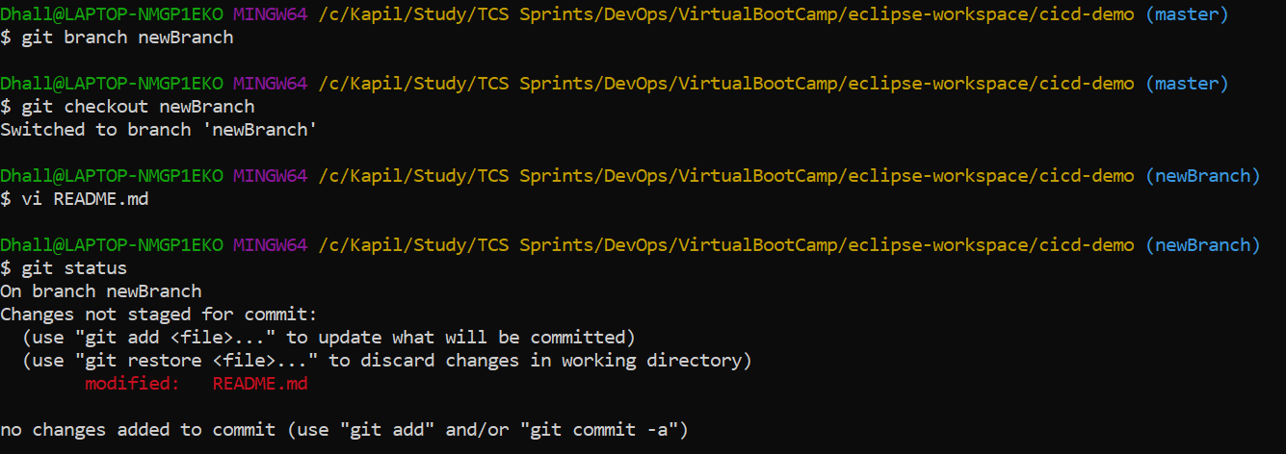

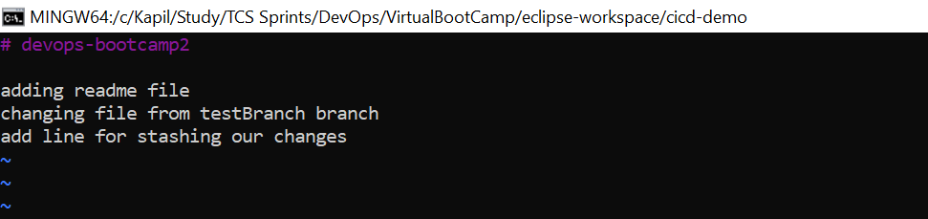

We do not want these changes now, so we will run **stash** command – **git stash (**To save the changes, when they are not in state of commit)

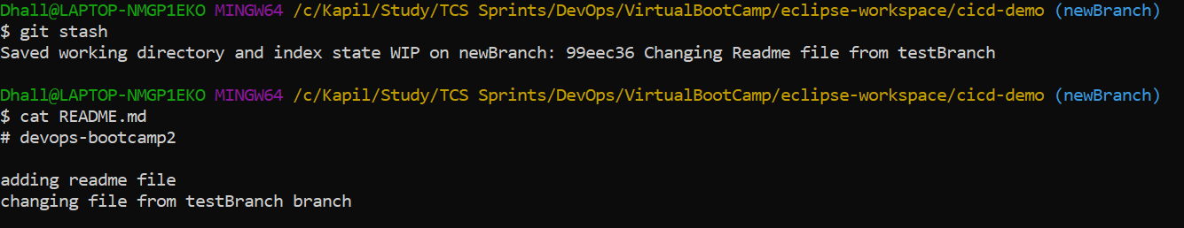

**git stash -u**

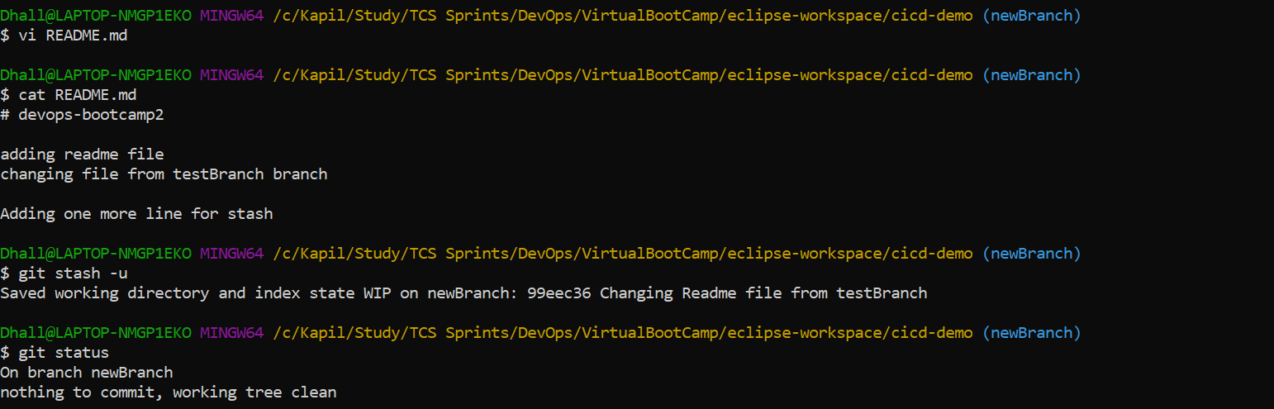

git stash list - To List the stashes created



git stash apply - To get the stashed work back.

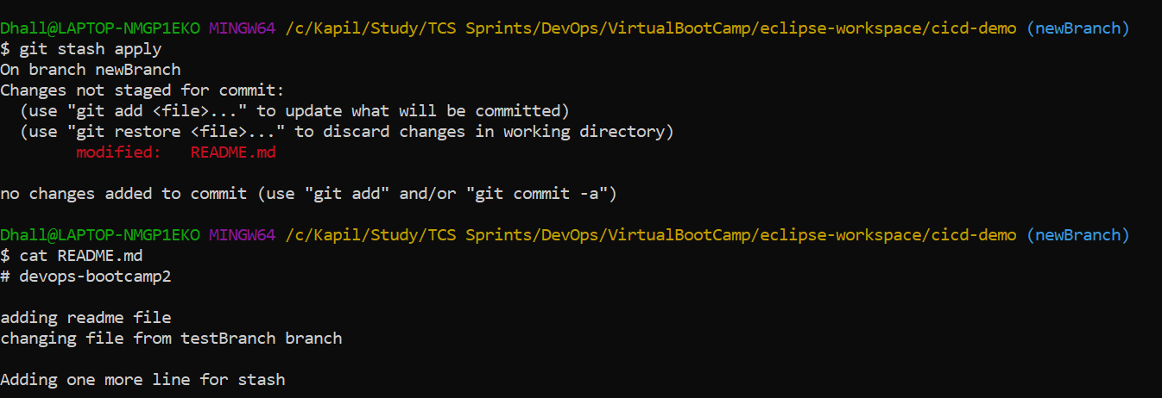

git log - To get the context and history of logs of a repository

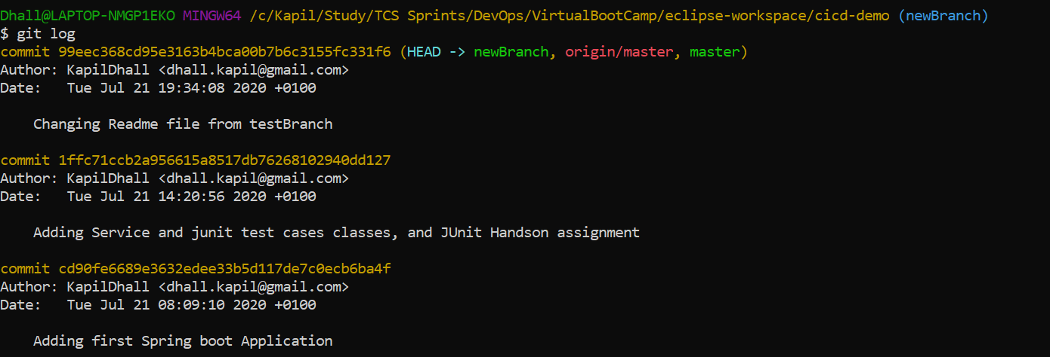

Git rebase - To Copy and Store a set of commit outside of our repository.

Create new branch.

Add and commit rebase.txt file in master branch.

Verify using git log

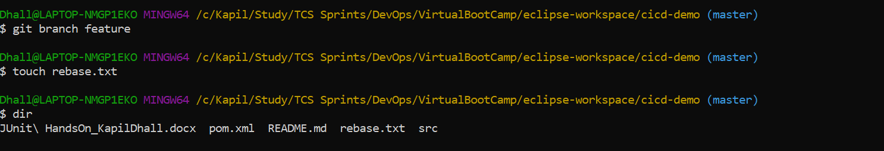

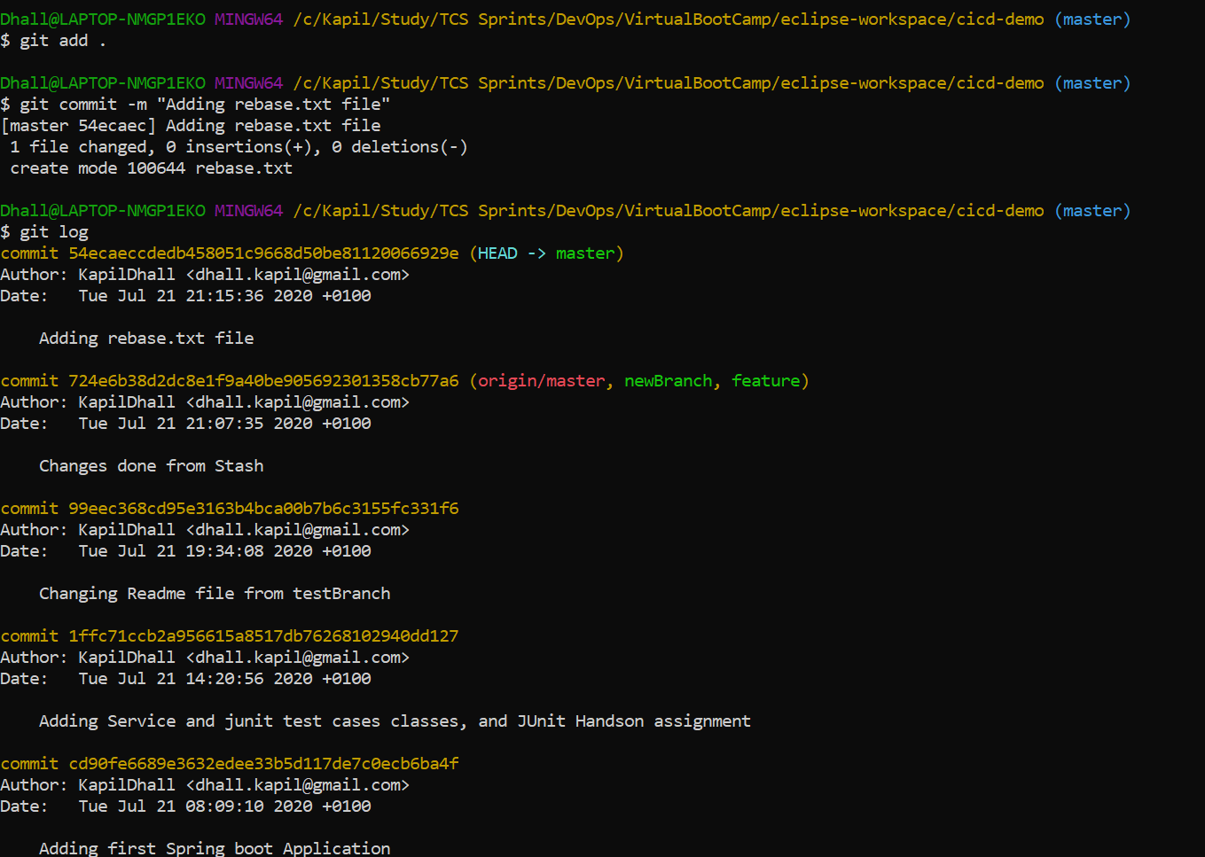

Now switch to feature (new) branch and check using git log.

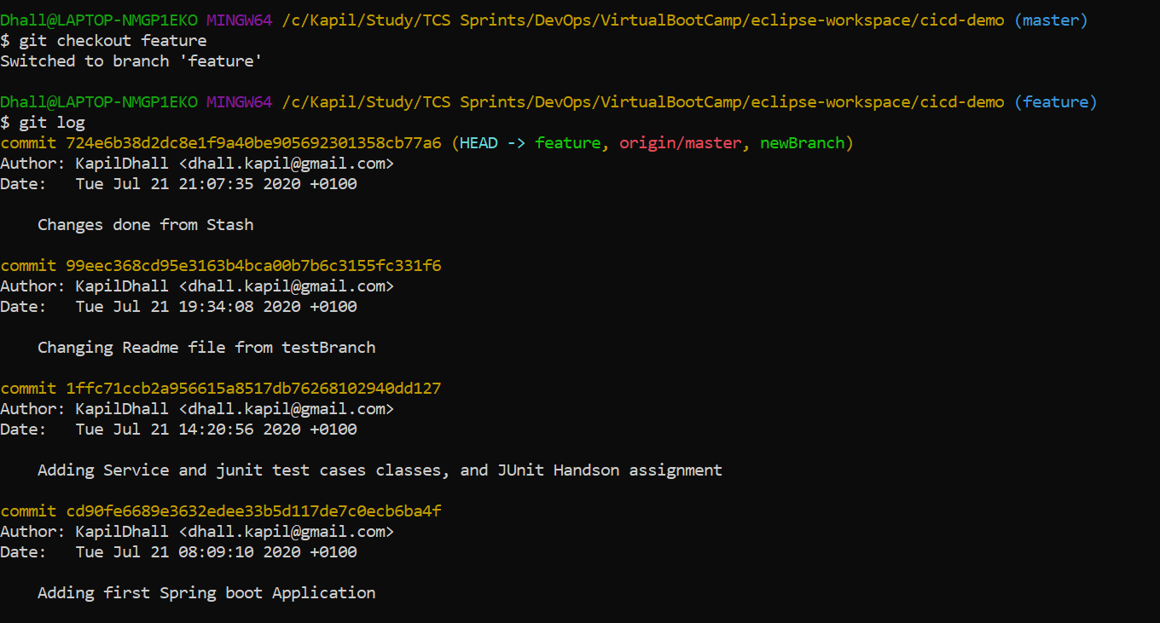

Add rebase.txt file and make changes. Add and commit changes and verify using git log

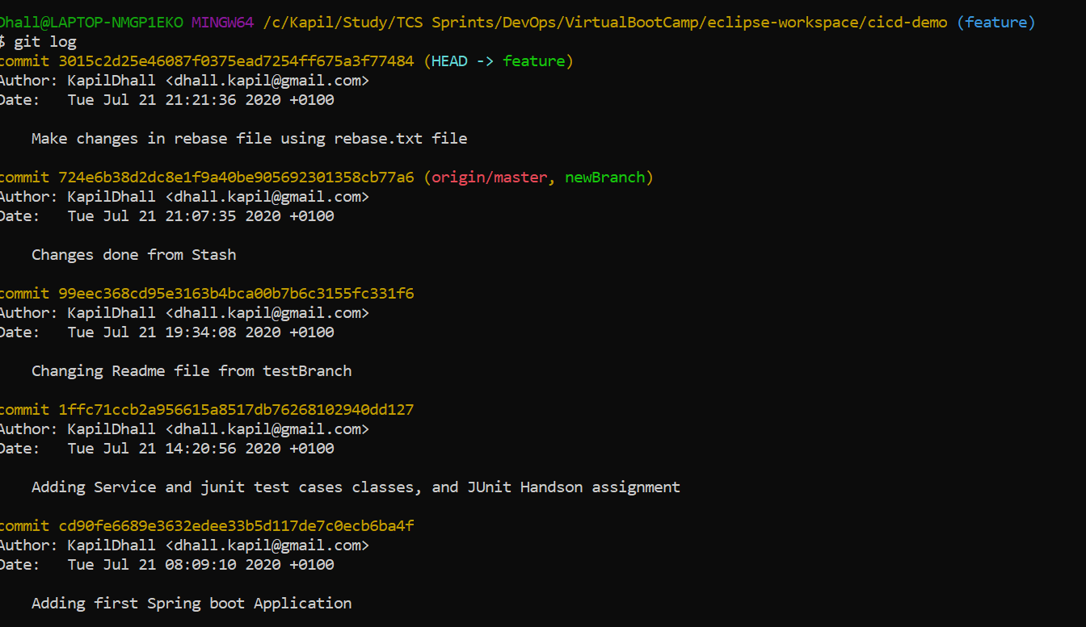

Now switch to master branch and run git rebase command:

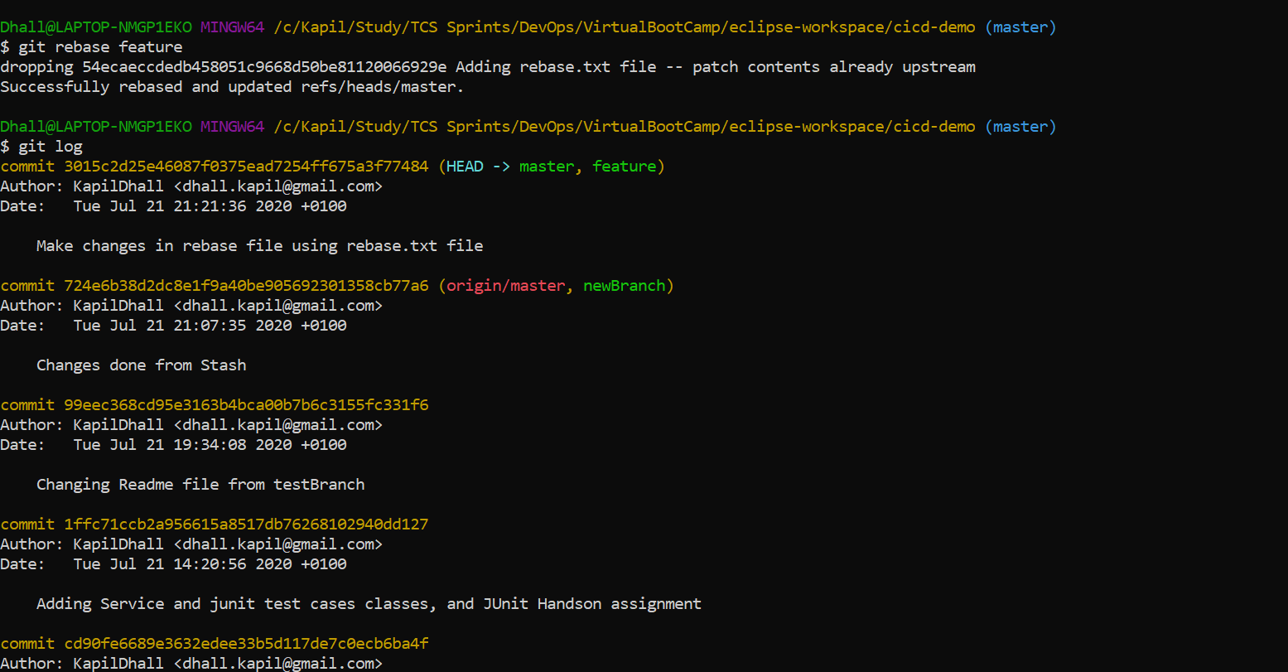

Git revert - To revert back to the previous version of the file

Create revert.txt file for this exercise. Commit this file.

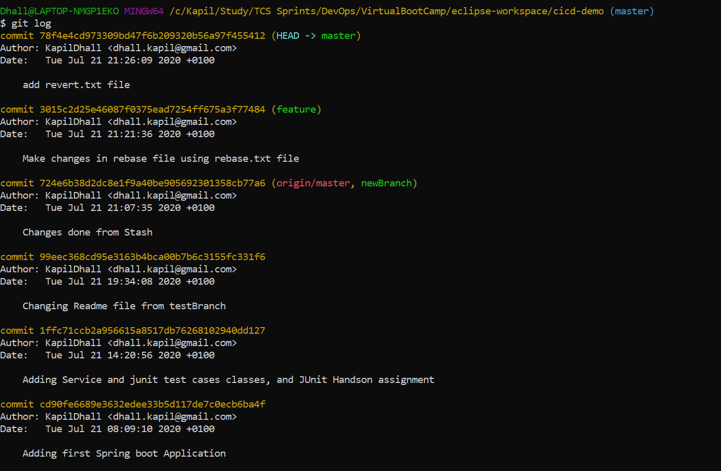

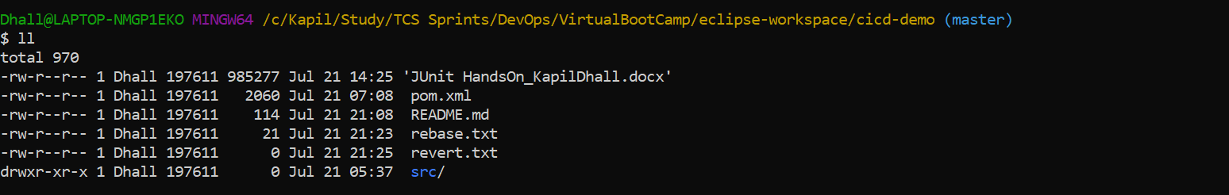

Run git revert command using last commit and verify changes are reverted. Revert.txt file should not be present

